Marcel Duchamp’s Fountain
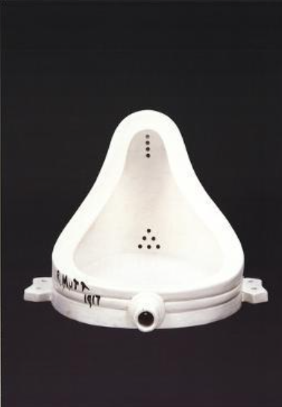
Marcel Duchamp’s Fountain
Duchamp displayed as part of his “ready-made” sculptures (Goldsmith, pg. 201). He presented the artwork as part of the ordinary industrial objects which would stimulate art lovers to question the real meaning of art. The Fountain is among the most famous artworks by Marcel Duchamp. It is considered one of the most iconic works of art from the twentieth century. The art included a standard urinal that is represented from the back for the purpose of exhibitions. The supporters of Duchamp explained that the industrially produced urinal was produced to abstract its beauty. As Danto explains, the beauty in a piece of art is internally based on the meaning of the piece of art. Danto’s view of the work is that the beauty of the art was an incidental outcome of the work of art produced for other intentions (Danto, pg. 62). The art is seen as part of the beautiful works of Duchamp which promotes his belief that modern plumbing in America was among its significant contributions to civilization. Although the original work drawn in 1917 was lost, Duchamp authorized the replication of the art in 1964 (Goldsmith, pg. 201).

Work cited
Goldsmith, Steven. "The readymades of Marcel Duchamp: The ambiguities of an aesthetic revolution." The Journal of Aesthetics and Art Criticism 42.2 (2013): 197-208.

